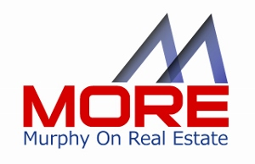

Lender Endorsement Letter for Listing Agent Prospective Seller

DATE
Listing Prospect
Address
Town, City, Zip

RE: Agent/Team Introduction

Dear (New Listing),

We are delighted that you are considering (Agent Name) of (Agent Company) to professionally market your home.

I would like to introduce myself (Name of Loan Originator) and (the Company Name), as an integral part of the (Agent or Agent Team). As an active member of the (Agent/Team) we play an aggressive role in the marketing of your property.

When you list with (Agent) you benefit from extended service levels of the Agent, their company and our (Lender Name) network. When you hire (Agent Name), we begin a diligent partnership effort to not just pre-qualify but to strive for pre-approval for prospective buyers before you accept a contract, preventing future complications. We will also consult with future buyers to secure the best financing plan for their needs.

The (Agent Team Name) and (Lender Name) maximize marketing efforts by offering no obligation pre-approval services displayed on print media, classified ads, printed brochures, virtual tours and web markets and automated Voice Response Systems.

If your next home will remain in our area, I can offer you a pre-approval services to accompany the offer on your next home, to minimize concerns and save time when you select your next home and to help align with the new TRID timelines.

It is my goal to support (Agent Name) to ensure that you are more than satisfied with your agent partnership and provide a high quality real estate experience with a minimum of complications.

Feel free to contact me if you have any questions on the sale of your existing home, or the purchase of your next one. You can reach me at the contact information listed below, or through your agent, (Agent Name) at (cell number or email).

Thank you for considering (Agent Name) and the (Lender Name) team to serve your real estate needs. We look forward to serving you.

(Loan Officer Name and Contact info)

