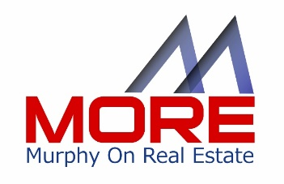

Lights! Camera! Action!

Top 10 Video Tips For GREAT Video

Did you know…?
- 96% of consumers state that they find videos helpful when making purchase decisions online
- 52% of consumers say that watching videos makes them more confident in purchase decisions*.
- 76% of marketers plan to add video to their sites, making it a higher priority than Facebook, Twitter and blog integration**.

So it’s clear that the consumer loves video, but too many agents haven’t figured out that video is a critically important component to an effective marketing campaign. In addition, agents can use a little help on how best to use real estate videos to expand their reach, boost engagement and create real differentiation in their brand.
Just to be clear, a virtual tour is not what we’re talking about here. A virtual tour is a great tool, but if you are looking for real differentiation and “stickiness” a personalized walk through tour of a property is more likely to win out over a series of photos that look like a tour versus a real person walking a prospect through a property on video. This is about using video in multiple ways to engage buyers, sellers, prospects and more with who you are, what you do and where you do your business differently from and hopefully better than your competition.
Video is a clearly a winner in the engagement for prospective buyers and a marketing must for sellers. Here is a checklist of ideas and recommendations to make your video’s rock. We’ve taken a few tips from experts like Michael Krisa, (aka “That Interview Guy) to help us help you!

Top 20 Tips for Your Video Checklist

- Whether you are using a tablet or smart phone, turn the setting to “AIRPLANE MODE” to avoid distractions while you might be shooting video.

- Do hold the camera the right way: If you are using a smart phone, hold it horizontally, not vertically to avoid the black bars on either side.

- Do look directly into the LENS not the screen. You want to connect with the viewer and the best way to do that is eye to eye contact by speaking and looking directly in to the lens, not the screen

- Using video provides the transparency for the viewer to know, like and trust you before they even meet you! For that reason, when you are looking into the camera, be conversational! The more natural the better. If you mess up (which is inevitable, especially when you are fairly new at using video) there’s a handy-dandy button to DELETE and start over. No heavy scripting necessary. Make an outline of top points you want to make and speak to those points as if you were speaking directly to another person behind the camera. This will help immensely

- Make ‘em short! Most people have a very short attention span. Your best bet it to make those videos run less than 2 minutes. Longer videos don’t keep the prospect engaged so short and sweet is the winning combination

- Use a Tripod: Nothing is worse than looking at video that is shaky and unprofessional. A tripod is inexpensive and easy to store. You can’t afford an amateur looking video just because it appears unsteady and distracts the viewer.

- Invest in an exterior microphone. Viewers will forgive mediocre video, but won’t stick around if the audio is bad. Exterior microphones are an easy investment and when used to “interview” and looks and feels more professional and can insure better audio. Holding a hand held while you interview also makes you look like the star/authority.

- Why not invest in a microphone “flag” box? Look like a major network when you have a customized flag box on your hand held microphone. They are inexpensive and it creates a true “celebrity authority” when you are covering an event, or interviewing. When you are in front of the camera, this differentiation can make a world of difference between top professional and amateur. Google “microphone flags”

- Be sure you have clarity in the title of your video so the viewer knows what they are getting. Be specific – The 5 biggest mistakes, the 3 things every buyer should know, etc.

- Start the video being on camera so to introduce yourself and what is to come. This will help connect the video with you as the “star” and begin to create your brand and boost visibility.

- Depending on what your subject for the shoot is, for larger venues, invest in a wide angle lens to capture the space of the venue, or large rooms in the property

- Dark videos that are hard to see won’t work. Be sure you have good lighting, or plenty of natural light to ensure good visibility. You can also pick up some lighting from Amazon.com for those subjects that need a boost.

- If you are shooting video of a specific property, use the address in the video title for better search engine optimization

- Always add your contact info, logo, name in the first part of the video and close with the info as well with a call to action to invite the viewer to the next step when appropriate. Do also add your phone number right on the video so a potential buyer can pick up their phone and call or text you.

- Do establish your own YouTube Channel complete with playlists. When you add your videos to specific playlists, they will search more easily and be easier and quicker for the viewer to find on your channel. Google owns YouTube, so you want to take advantage of the largest search engines in the world to work for you!

- When you shoot the video, add text to the video to help the viewer to recall important info like how many bedrooms, baths, etc.

- Don’t limit your videos to properties only! Shoot interviews of your local vendors, what they offer, why they love doing business in your area. Cover community events, holiday parades, etc. – be a part of the community!

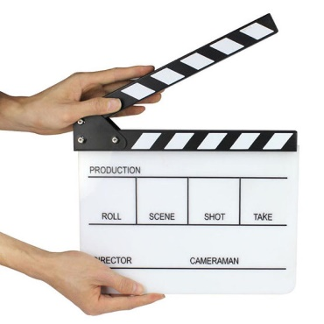

- Create a “lifestyle” video around the community you are profiling. Highlight the benefits of living in the city or town, the vendors, the local history, special amenities, and reasons why someone would want to live there.

- Practice, practice, practice. The more you do, the better and more natural you will look and feel which will produce better videos!

- Have FUN! Smile and enjoy the process. Even include a few “bloopers” will make your video fun to watch!

*Invoto
**Social Media Examiner

